Physics of Neuroweapons
by Michael J. McCarron
[rough draft version 7/29/20]

Gravitational Basis of Neuroweapons
Some suppose that to have psi or faster then light propulsion one must come up with a new physics that is not Einstein’s General Relativity (GR). However, this is not mandatory for psi or faster then light propulsion. The question of Gravity is a central question to Einstein’s equations, yet missing from GR is the explanation of Quantum Gravity. This remains an open question in Quantum Physics. Below we will review one possible explanation of Quantum Gravity in the work of German Physicist Burkhard Heim. It is important to realize that what we know of Gravity is still very much an open investigation with no firmly established principles or any quantifiable explanation for how Quantum Gravity works. In regards to explanations for Quantum Gravity we will also encounter the Quantum Field Theory founder Pascual Jordan, who as a Nazi scientist worked extensively on Gravity and Quantum Biology.
The conception in many conspiracy theory explanations of Neuroweapons is that cell towers are the methodology for such propogation. Though it is true that potentially Microwaves, as used in cell towers could be used to send out EM waves. From the Documentation from proponents of this technology it becomes clear that the cell tower explanation may indeed be disinformation. In the High Frequency Gravitational Wave section of this chapter we will see documentation by former Lockheed Engineer, Dr. Robert Baker to embed HFGW receivers and transmitters in cell phones. Thus making the need for any cell towers obsolete and unneccessary. Although, it is still a valid concern regarding the 25th Frame effect in inducing deeper trance states which can be manipulated through Gravitational Waves and their conversion into EM radiation to affect brain function through video screens, not reliant on cell towers, including 5G.
The question becomes where and how did Gravitational Wave technology come from and who developed it. Regarding this we would have to look at a avowed Nazi Quantum Physicists, credited as one of the founders of Quantum Mechanics, Pascual Jordan and the conscripted German soldier Burkhard Heim who went on to propose a Gravitational Theory that expanded on Einstein’s General Relativity into a hyper dimensional space where others have noted Gravitational Waves can also propogate. Before deep diving into Jordan and Heim’s work in Nazi Germany and post-war Germany it is worthwhile to take a look at the development of these ideals as they propogated through the post-war Soviet Union and UKUSA defense industry research. Also, of note is Austrian biologist Paul Kamerrer (d. 1926) who based his ‘law of seriality’, that synchronicities occur through a gravity like field, he died of a suicide, his writings indicate a typology associated with ‘Targeted Individuals’.
This technology in the early days, was not referenced as Neuroweapons, but rather as ‘Transcommunication’. There are several explanations for the ability of non-local communication, most of which incorporate gravity and neutrinos. Several researchers in the Soviet Union have credited the work of Pascual Jordan on gravity as to the source of their investigating gravitational waves for the purposes of Neurowarfare. American researchers have also noted the role of Gravitation in psi or ‘transcommunication’ technology. For instance in the Soviet Union the work of Dubrov which calls for ‘non-local transference only in gravitational field, which he based on the work of L.L. Vasilev” (DIA, 1975, 16-17), it is also incorporated into the work of Bunin in his creation of a signal transmitter/reciever using GW in 1972, Dubrov credits Bunin with his knowledge of biogravitation, also mentioned in Dubrov’s work is that of theoretical physicist K. Stanjukovic. While previously we mentioned the work of Matvei Bronstein who was killed in a Stalinist purge, the purges themselves may have been a Nazi Psyop, just before the war started, as the purges occurred in 1938 after the ending of the Nazi-Soviet military cooperation pact in 1932. Similarly a researcher in Astrocosmology was the imprisonment of Kozyerev, who did not use the term gravitation for his explanation but seems to correlate what he called ‘time’ as ‘gravitational effects’, a theory formulated in the Siberian gulag he was sentenced to. Again, there is a pattern of people involved in gravitational explanations being targeted by the Stalinist purges, while Jordan is working on his own Nazi technology based on the same.
In the United States academic’s have cited the work of Haaken Forwald (1897-1978) who proposed in ‘Mind, Matter and Gravitation’ (1969) that psi was gravity based. W. G. Roll, originally a German national, immigrated to the US and proposed that ‘psi’ field which we would now call ‘gravitational field’, he also worked with Nazi Parapsychologist after the war, Hans Bender on a phyiscal explanation of ‘Psi’, Bender, as noted before, worked also with Jordan and Heim, as well as Capt. Hans Roeder, post-war on a physical explanation for psi on which to base a real scientific technology. Bender is not outside American influence either, as he is noted to have worked with the DIA in Germany on ‘hauntings’ at an American base in Germany. In the DIA report that speaks of this collaboration, an American academic, Elizabeth Rauscher, was also consulted where in the work cited in the report ‘Higher Diminesional Geometrical Models’ she also used an higher dimensional or hyper space, in this case 8d, to explain psi, again only gravitation could be both in 4d and hyper dimensions, Dr. Robert Baker, “An important point about Gravitational Waves is that they propagate in sub-space or hyper dimensions beyond the 4d we inhabit. (Baker, 2017, 28)”. An interesting contribution to the gravitational explanation for Psi came from former DoD analyst, Lt. Col. Thomas Bearden, who worked on analysing Soviet technology in this area where he explains that construction of electrogravitational waves and beams. The destructive interference of ordinary EM waves produces gravitational potential energy. Release of EM leads to bleed off of a 5d gravitational potential as EM, bottling up of EM leads to 5d Gravitational potential, similar to Gerstenshtein Effect and Li Effects discussed in HFGW section below, as ordinary 4d gravitational force. These and other ideals are analogous to B. Heim’s explanations of Psi and gravity.
Digging deeper into Soviet research, it was L. L. Vasilev that proposed the gravitational hypothesis, first formulated by Jordan. Vasilev also referenced neutrinos, another particle, like graviton, that is thought to be able to penetrate almost anything (DIA, 1975, 7-8). L. L. Vasilev was a key assitant to Bekhterev in the joint German-Soviet Brain Institute. Some of his early research involved the use of hypnosis to enable better psi transmission.
“...suggested that the interaction between the gravitational field and some existing but unexplained factor, possibly by the cerebral matter itself [possibly magnetite or Microtubules], might be involved in telepathic communication. He also suggested that thought transmission might be connected with the laws of cybernetic systems. Vasilev also referred to the action of the neutrino particles formed during nuclear reactions. If it could be established that such particles (neutral charge), move with speed approaching C [light] and are capable of penetrating obstacles of enormous mass, are generated during the neuropsychic activity of the brain, it might conceivably be shown that these particles serve as the mechaism for telepathic transmission.” (DIA, 1975, 16-7)

Vasilev went on to publish some of his unclassified work in ‘Telesuggestion’ (1962) and ‘Experiments in Mental Suggestion’ (1965). As noted he influenced the work of Dubrov.
Aleksandr P. Dubrov in a seminal article from 1973, ‘Biogravitation and psychotronics’ noted:

“By the term biograviatation, we designate field energy system. The biogravitation field is universally convertible...it is capable of transition into any form of field and energy, therefore a unified field theory.”

Dubrov notes that it is a ‘unified field theory’ which is also a pointer back to Jordan’s contribution to the Soviet understanding of Gravitational effects on biological systems.

Dubrov goes onto explain what Biogravitational effects are:
Biogravitational Forces:
a. act at close or long range;
b. Can be directed and focused;
c. + or -;
d. They can carry information;
e. Convert the energy of field into matter with weight (mass);
f. Field persists in absence of source; .
g. can transition to any form of field or energy;
h. Bound up with the change of symmetry groups and with distorting of space at the submolecular level of biological structure
(Dubrov, 1973, 313)

Referencing the work of Bunin, this reference also touches on the work of Dr. Michael Persinger, see below, regarding the effects of biogravitation on thixotropy in water, which also may have an effect on brain microtubules, and hence consciousness:

“For a variable biogravitational field, according to V. Bunin, it may be accepted that gravitational radiation is contingent on the phased oscillations or rotating of hydrogen electrons or atoms of water in H2O [see Persinger below and in Quantum Consciousness section, thixotropy] a living organism may be both a receiver/transmitter [See Bandyapadhya in Quantum Consciousness section, retinal antenna] of gravitational waves, evaluating the minimum level of a receivable signal:

It is illuminating in the following section that Dubrov talks of directing or focusing the gravitational radiation, as this is exaclty the device designed and built by Bunin in 1972:

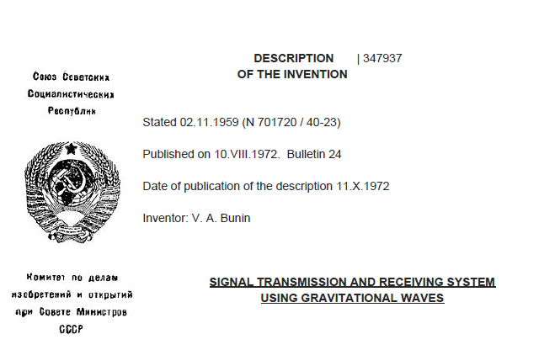
English Translation of V. Bunin’s 1972 Soviet Patent for GW Signals

Later these same principles are applied in Dr. Baker’s HFGW Transmitter/Receiver, although it is possible he had already developed these ideals himself in 1961 at Lockheed:

“we should mention in this connection that a number of researchers have studied gravitational radiation in respect of rotating particles. This radiation has been studied by quantum theory methods in respect to the approach of a weak gravitational field in the case of the gravitational radiation of a synchotron of a particle moving along a circle. The most interesting thing for us is this research author’s conclusion that the major part of the radiation is concentrated in a small angular region near the particles place of rotation and can thereby be directed.” (Dubrov, 1973, 316) Which is also noted by DIA HFGW proponent, Paul Murad: “A similar thing occurred several years ago concerning the idea that gravity waves obey a law of optics and could essentially be which has interesting consequences.” (Murad, 2006)
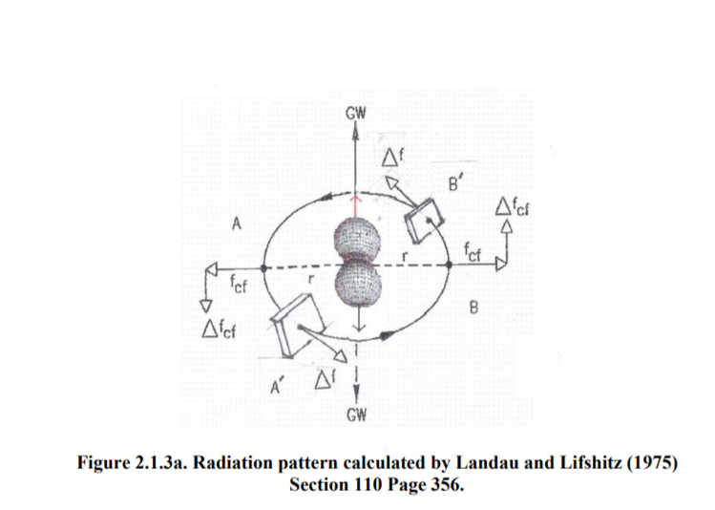

Dr. Forward is remembered by Paul Murad, a DIA HFGW investigator, referencing back to Forwards early contributions to gravity theory and control:

“Bob Forward .... I had no real idea of how impressive he was. Mead had supported him when he looked at exotica such as anti-matter propulsion and tethers. I found that in a 1963 paper, he talked about controlling gravity with electric and magnetic fields, something that Einstein in his recently translated papers from 1920 said the same thing. Forward looked at gyroscopes about the same time as the Russian Kosyrev also investigated such effects.” (Murad, 2006)

Dubrov, like Jordan, also touches on gravity on Quantum Biological subjects, here specificially protein synthesis, which later we will encounter the resonance concepts in Cosic’s work (see Quantum Consciousness Section):

“...the formation of a gravitational field, with all its attendant consequences, is also possible. In this way, theoretical calculations support our hypothesis that a biogravitational field may result from changes in the conformation of protein molecules subjective to compression, tension and deformation.” (Dubrov, 1973, 316)

“The process by which a constant biogravitational field is formed can be hypothesized in a similar way using traditional notions. Considering that, during that change in conformation of the protein molecules from a state of random aggregation to an ordered crystalline state, not only does a phased oscillation of the atoms occur but the atoms move closer together, it is to be expected that a considerable constant Bio-Gravitational field will appear, owing to the great increase in the density at micro level, of the biostructures.”

Aleksandr P Dubrov, a Moscow physicist, has proposed a model for paranormal perception based on a gravity-type interaction. In this concept, he condiers it theroretically possible for aggregates of biological molecules that are in a loosely bound state (liquid crystal type) to create very weak quasi-gravitational field effects. This would result, in his view, from variations in gravitational attraction forces arising form change sin relative molecular spacing. The net effect would be a very small gravitational-type perturbation. This would be in addition to nomral gravitational attraction and gravitationa perturbations which are theoretically possible from thermal oscillations. [is this similar to Heim’s theory on paranormal acitivity?] (DoD, 1978)

He suggests that a constant BioGravitational field results from specialized brain structures when strongly excited (epiphysis, hypophysis).

“In psychology, new light will be thrown on one of natures greatest secrets, the workings of the brain. A better understanding of mental processes, the brains integrating activity, the coding of information and partcular states of consciousness can be achieved only with the aid of the bioGravitational hypothesis.” (see V. Pushkin psychological biogravitational hypothesis ‘Autogravitaija (Autogravitation).’ in Socialisticeshajaindustrija Moscow 9 Sept 1973)

From Dr. Dubrov’s work we can see the direction and correlation with actual inventions in the form of Bunin’s Gravitational Signal Transmitter (1972), as well the tendency to associate gravity with influencing the Brain. The subsequent publication in 1973 of Dubrov’s paper shows that as early as the 1970s at least the Soviets were working on weaponized versions of Gravitational based technology for the purpose of remote influencing.

Modern Theories of Gravity and Remote Sensing
One of the most important North American researchers in the role of gravitation, electro-magnetism and microwave radiation in remote sensing was Dr. Michael Persinger (d. 2019), who as the son of a Naval Intelligence officer and also research collaborator, got interested in the ideal of EM waves and remote sensing at an early stage, a subject that has occupied his entire career. He is known to neuroweapons developers as evidenced in the writings of Lockheed engineer, Dr. John Norseen. As a professor at Laurentian University in Canada, he had an experimental lab set up that could look into these areas with some level of public financial support. His experiments are, as we should expect with plausible deniability, doubted, controversial and often on the receiving end of extreme emotional counter arguments for such a quantized scientific experimentation that he employed in his understanding of the physics behind, entanglement (he calls ‘deep correlation’), brain physiology, brain microtubules, Schumann Resonance, and other areas, all of which are directly related to technologies outlined and documented in Neuroweapons development.

Persinger related on the role of gravity in deep correlation:

“...the theory developed by Hu and Wu (2006a, b; 2013) that the primary source of the macroscopic manifestation of quantum entanglement originates from primordial spin processes in non-spatial and non-temporal pre-space-time and involves gravity. When one considers the measurement by Fickler et al (2013) that single photons (even though they differ by 600 in quantum number as long as they exhibit quantized orbital angular momentum from helical wave structures) can exhibit excess correlation, then the potential for remote sensing become feasible.” (Persinger, 2015, 660)

Persinger in another paper makes the case for graviton, the particle form of gravity, as the means of psi:

Measurements have shown an inverse association between natural electromagnetic intensities and irradiance from background photons. In general for every ~10-12 W·m-2 increase in photon radiant flux density there was a 1 nT decrease in intensity of the ambient static (geo-)magnetic field. Dimensional equivalence of the two quantities required the latter to be multiplied by ~10-3 A·s-1 . Assuming ~1079 particles universally, each with a unit charge, the rest mass of that particle would be ~10-65 kg or the median solution for the graviton. On the bases of the calculations and conceptual inferences, entanglement phenomena across the space-time that defines the universe could be mediated by a gravitational field whose quantized component, the mass of a graviton, when expressed as the square of the hypothetical entanglement velocity, is light. This velocity (1023 m·s-1 ) is derivable from independent approaches that require the consideration of the universe as a single set. If this inference derived form empirical measurements is valid, then there is additional evidence that “excess correlation” and entanglement of photons anywhere in the universe is mediated by quantized components of a gravitational field that is contained within the total spatial and temporal boundaries. (Persinger, 2015b)

Persinger, in this same paper goes on to clarify that entanglement or deep correlation occurs in a singular universe, the view that the universe as proposed by theoretical physicists, Hu and Wu, that everything is connected, or a full graph. Persinger remarks, “the essential premise is that the physical mechanisms that serve as the substrate for entanglement reflect the properties of the entire universe as a unit within which differences in time may be less critical” (Persinger, 2015). Again, one should be aware that graviton and gravitational waves are indeed non-local, both spatially and temporally, adhering to the quantum physics definition of non-local. We can see from Persinger’s research that he directly relates ‘remote sensing’ with gravitational effects at the least. In another paper, he relates that entanglement and remote sensing are directly related: “two-photon, 3d entanglement may be capable of applied quantum communication [transcommunication]. Such quantum energy teleportation may not be limited to distance [or location: x,y,z,t].” (Persinger, 2014). We will encounter Dr. Persinger more in the Quantum Consciousness section where we will learn about his ideals regarding neuroscience, entanglement and changing angular momentum as the means of remote sensing, which of course is common to all waves, whether EM or Gravitational.

In the following sections we shall read about the history of the development of Gravitational Waves and their detection. Starting with the work of Pascual Jordan, Burkhard Heim, Joseph Weber, and the work of Dr. Robert Baker with HFGW.

Pascual Jordan (1902-1980):
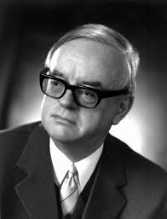
Pascual Jordan received his Habilitation (Ph. D). in 1927 at age 24 in Gottingen. After graduating he received a Rockefeller Grant to study in Copenhagen, the center of the dominant QM interpretation. In 1929 he was a professor at Rostock, he had a stuttering problem which kept him from more prestigious postings. At Rostock he became a propagandist for the Nazi cause, he later became the same for the Christian Democratic Union in West Germany. His sentiments at the time of his appointment to Rostock are characterized by Beyler:

After the Nazi takeover, Jordan put his own name to similar but even more vehement opinions. The physics professor and new NSDAP member wrote in the Rostock University student newspaper in May 1933 that ‘armed with fundamentally unlimited power...this [ongoing] transformation [of the state] levis the ‘claim of totality’ to reform incisively all domains.’ An antiliberal variation appeared in his 1935 book Physicalisches Denken in der neuen Zeit, from the same publishing house as Dutsches Volkstum. The book was, inter alia, a proclamation of the service that science and technology--above all, military technology--could offer the power-oriented modern state. The ‘technical modernization of the apparatus of government,’ he specified, occurred through the replacement of the old parliamentary forms… with authoritative and dictatorial methods.’ Elsewhere, in a report to the Reich education ministry on the 1936 Unity of Science Conference in Copenhagen, he endeavored to convince the authorities of the possible role of modern science in the struggle against ‘Bolshevism’ and the ‘materialistic camp’ in general. (Beyler, 1996, 259)

An avowed fascist and racist from an early age, after having been a Protestant Fundamentalist, his scientific interests diverged from his cultural interests, on one hand he worked with such infamous Jews in Physics as Einstein, on the other hand calling for their removal from academia. In 1942 he attempted to start a Physics journal dedicated to the industrial scale development of Quantum Biology, of which he was the true founder, not Heisenberg, who studied his thoughts on Quantum Biology. Oftern Jordan’s contributions to Quantum Mechanics are minimized due to his Nazi past. During the war he ostensibly served in the meteorological service until 1944 when he received a Professorship in Berlin, worked with Berlin-Buch Brain Institute, and was employed, like Capt. Roeder, at the secret technology office of the Kriegsmarine (German Navy). After the war eventually ending up in the 4th Reich hotbed of Hamburg where he was a professor in 1947.
Pascual Jordan worked with Burkhard Heim to set up experiments, but never got funded. Pascual Jordan was also at MBB when Heim made his presentation in 1969. Pascual was also in contact with Hans Bender, Bender records in a letter to Duke University parapsychology, Dr. Rhine, that he had exchanged information regarding parapsychology with Jordan in 1949 (Asprem, 2013, 410). Jordan, already in1936 had written regarding parapsychology and quantum physics[1]. As we shall read later, he very much anticipated developments in Quantum Consciousness thus informing the work of Dr. Norseen.

His pet theory (Schoer, 2003) was gravitation with a time-dependent gravitational coupling. His name is part of what is known as the Jordan-B-Dicke Theory. Which calls for supplementary gravitational fields to what is normally considered, see below. As Schoer has noted:
“Jordan was a visionary revolutionary” (Schoer, 9). He was guided in his early work by Max Bjorn, and his papers helped solidify Heisenberg’s claims. He is considered a co-founder of Quantum Mechanics, but due to his Nazi beliefs his contributions are largely minimized, although one can see the importance of his intellectual scientific achievements in being considered as one of the founders of Quantum Mechanics. He also founded a form of mathematics known as Jordan algebras. In 1926 he worked on quantization of wave fields using Quantum Field Theory, which differs from typical Quantum Mechanics.

In 1929, he presented on QFT at the Kharkov (Ukraine) conference, which was a German language based conference though in the Soviet Union, part of the German-Soviet technological cooperation:

In 1929 at a conference in Kharkov, Jordan gave a remarkable plenary talk (the conference language at that time was still German). In a way it marks the culmination of the first pioneering phase of QFT; but it also already raised some of the questions which were partially answered almost 20 years later in the second phase of development (i.e. renormalized perturbation theory, gauge theory). In his talk Jordan reviews in a very profound and at the same time simple fashion the revolutionary steps from the days of matrix mechanics to the subsequent formulation of basis-independent abstract operators (the transformation theory which he shares with Dirac) and steers then right into the presentation of the most important and characteristic of all properties which set QFT apart from QM: Locality and Causality as well as the inexorably related Vacuum Polarization.
....These statements are even more remarkable if one realizes that they come from the protagonist of field quantization only two years after this pivotal discovery. When I accidentally came across the written account of this Kharkov talk, I was almost as surprised as I was many years before when it became known that Oscar Klein (with whom Jordan collaborated in the 30s in Copenhagen) had very advanced ideas about nonabelian gauge theory (which were published in the proceedings of the 1939 Warsaw international conference [33]). Apparently all of the classical aspects of nonabelian gauge theories and some quantum aspects were known before the second world war. Apart from QED the postwar interest developed away from gauge theories into pion-nuclear physics. The great era of gauge theory in connection with strong interactions had to wait 3 decades.” (Schoer, 2003, 8)

It is interesting to note that Jordan was decades ahead of the rest of the physics community in the 1930s, an era when he is also formulating his ideals on mass scale Quantum Biology research. The modern antecedent to Jordan’s thought are contained in Loop Quantum Gravity theory. According to Schoer Jordan’s expectations about QFT are now in Local Quantum Physics (LQP):

“...although important ideas in the exact sciences may get lost in certain situations, sooner or later they will be rediscovered and expanded.” In this sense it is in relation to the rediscovery of key concepts of QFT from 1939 that were lost during the war and not taken up again for 30 years. Noting such work at Oscar Klein, all of the classical aspects of non abelian gauge theories and some quantum aspects were known in 1939 but lost for 30 years (Schoer, 8-9). For Jordan gauge theory was important in 1929.

As mentioned the true founder of Quantum Biology was Pascual Jordan. Quantum Biology these days is thought to have begun with Hiesenberg, who was never a member of the Nazi Party, in actuality it was started through a synergy of ideals exchanged between Bohr and Jordan. Jordan heavily influenced Heisenberg, though they disagreed on many points, Werner Heisenberg did accept the target-theory approach. Jordan’s contribution is largely buried, suggested by scholars due to his Nazi beliefs, which also could be explained if he was continuing research as obfuscation or hidden work. He worked with a team of Genetic Researchers at the Berlin-Buch Brain Institute. He collaborated with this group from the 1930s to the end of the war. He also sought to work with the Nazi Reich in establishing a massive industrial scale Quantum Biology research sector within the assumed victorious Nazi Reich. His ideals were carried in the academic journal ‘Physis’ in which he propogandized for his scientific ideals. In 1942 Jordan started a journal Physis: Betrage zur Naturwissenschaftlichen Synthese. He was working with the censorship office on this, while also being dually recruited by the Propaganda Ministry for a similar project. (Beyler, 268). Dahn, has written regarding this period:

The second contribution, though, exemplified the way in which ideology could find its way into Physis—and into the plan for Europe-wide big science—as it was written specifically to pique the curiosity of well-positioned Nazi power brokers. Titled “Future Tasks for Quantum Biological Research,” it expanded on Jordan’s article in Deutschlands Erneuerung, outlining a detailed plan for a massive group of research institutes to investigate Jordan’s quantum biology—essentially prototyping his vision of big science. The “research center” envisioned was so costly and ambitious that “its realization would certainly presuppose the German victory as already achieved,” so it would “stand after the German victory as a symbol and representation of the unlimited means of power [Machtmittel] of the new Reich.” In charge would be a Führerinstitut, or leading institute, conforming to the Nazi Führer principle that a leader should be found in every area. At the end, Jordan slyly tied his proposed institute to another of the Nazis’ favorite bugbears, cancer, noting that all quantum biological research opened “new possibilities of attack against the cancer problem.”

This wide spectrum of articles makes the deeper designs for Physis clear: Jordan and Meyer-Abich aimed to create a leading (and the analogy to the Führer was intended) interdisciplinary, international, scientific organ, in the vein of Nature or the German Die Naturwissenschaften, that would institutionalize Jordan’s vision of big science in the “new Europe.” Demonstrating the quality, loyalty, and military value of German science to the Nazi state, Physis was to be a vehicle through which Jordan and Meyer-Abich could pull in financial support—and protection—for their monumental plan for a Europe-wide scientific enterprise operating on an industrial scale under German leadership.” (Dahn, 2018, 82)

To delineate the departments of the Quantum Biological Institute would undertake, in the first volume of the journal, Physis, contained Jordan’s elaborate plan for a quantum-biological research institute. Which envisioned 3 research groups: genetic research (on bacteria, yeast, fruit flies, etc.), protein research [RNA], and ‘warm-blooded [animals] research’ (Including topics such as serology [Vershuer-Butenandt experiments], immunology, oncology and mammalian genetics).

Jordan was in dynamic tension with the idealogical purity of the Hitler led branch of the Nazi Reich, for one he worked regularly with Jews in Quantum Mechanics, it was not viewed as Deutsch Physics: the attempts to rid Physics of all Jewish influence. Though he did manage to get official sponsorship from the Reich for his journal. Beyler notes:

The power structure of the Nazi state, despite the propaganda touting totalitarian unity, was a ‘polycracy’ of different power blocs [Himmler: North German (Hamburg) vs. Hitler: South German/Austrian] often with ill-defined and overlapping spheres of authority and sometimes with mutually antagonistic interests. This was especially true in science policy. Here there were long-standing conflicts between authorities who pushed for instrumental efficiency [Himmler] and those whose main interest was ideological purity [Hitler].(Beyler, 1996, 250)

One issue in Germanic Nationalist science is that of organacism, while the Reich itself was very mechanistic oriented. This dynamic between organicism and mechanics is one that is played out in Jordan’s mind. A German researcher, Beyler, writes regarding this:

“To win support for a quantum revolution in biology, Jordan sought to reconcile organicist ends-- the rejection of mechanistic theories--with physicalist means--the deployment of concepts, techniques, and metaphors derived from modern physics. Extending the quantum revolution also meant, for Jordan, seeking to link modern science and the Nazi state in mutual legitimation. He was partially successful in finding a niche for quantum biology in the ideological and institutional structures of the Third Reich, but only partially successful. Just as the intended conceptual and disciplinary bases of quantum biology were marked by unresolved tensions, so too the cultural meanings Jordan ascribed to quantum biology mirrored a volatile instability in Nazi ideology and praxis; professed allegiance to ideals of volkisch social harmony alongside the inmitigated exertion of authoritarian, technocratic power. In short, in its cultural meanings the target-theoretical organism embodied the precarious situation of modernity
in the Third Reich.” (Beyler,1996, 248-9)

Beyler continues to delineate Jordan’s organicist ends toward authoritarian science:

On the conceptual and disciplinary levels, quantum biology combined two trends that seem prima facie to be polar opposites. Starting in 1932, Jordan published several essays on biology that he intended as contributions to the ‘organicist conception of the world’ and to the concomitant rejection of materialism [Marxist Leninism]. Responding to criticisms of these speculations, he added from 1937 onward a quite different perspective appropriated from the ‘target’ or ‘hit’ theory in biophysics. Target theory was a statistical methodology for analyzing the effect of radiation or other physical agents on organisms. It hypothesized the existence of submicroscopic ‘targets’ that were affected--that is, ‘hit’--by the impinging radiation. Through the target-theoretical connection, quantum biology would acquire experimental technologies and theoretical models from modern physics. It would also become allied with a group of dynamic and well-supported researchers. (Beyler, 1996, 249)

‘Target’ or ‘hit’ theory was first introduced in 1922 by the X-ray physicist Friedrich Dessauer, professor of the physical foundations of medicine in Frankfurt. Parallel developments started in Britain with the work of J.A. Crowther and in France with that of Fernand Holweck. The theory gained in interest following a series of dramatic discoveries that focused new attention on physical experimentation in biology and on the microscopic or submicroscopic domain. The discovery of X-ray mutagenesis by H. J. Muller [go further into American Muller in Berlin, Soviet Union] in 1927 opened a new era in experimental biology. (Beyler, 1996, 253-4)

Boris Rajewsky continued the work of Dessauer, who went into exile in 1934. Rajewsky headed and founded the KWI for Biophysics in 1936. Another target institution was the KWI for Genetics, the Institute for Brain Research in Berlin-Buch, founded by Oskar Vogt with a twin institute in Russia. The work in Berlin-Buch was Russian geneticist Nikolai W. Timofeeff-Ressovsky. Target theory also influenced the founding of microbiology through phage research. By 1936, [Jordan] spoke enthusiastically of using physics in pursuit of fundamental problem of genetics, within the context of eugenics. In 1935, Timofeeff and Zimmer wrote a paper with CalTech’s German emigre Delbruck, which addressed the atomic-physical model of gene-mutation.’ Within the target-theoretical analysis of radiation genetics data, the paper argued that mutation was a ‘one-hit’ process, a single ionization produced by a quantum of radiation in certain receptive areas, a large organic molecule. Jordan argued that the gene was such a thing, the gene as a group of atoms.

Jordan is here speaking or alluding to the concept of targeting genes with waves or radiation. A specialty of one of his collaborators, Karl Zimmer of the Brain Institute. It is important to note that the working group at Berlin-Buch that Jordan was involved with directly led to the invention of Genetic Engineering. As well documented the Nazi scientific community was very interested in using Genetics to target those of other Genetic compositions deemed ‘non-German’. Beyler writes of this collaboration:

Jordan’s plans for restructuring biophysical research were directly linked to his target-theoretical contacts. Their importance to him is shown by the fact that during the war years he repeatedly attempted to be transferred to Berlin from his postings in the Luftwaffe meteorological service in order to be closer to the Berlin-Buch group. Despite the resistance of his military superiors, in late 1943 he succeeded--with Heisenberg’s help--in obtaining simultaneous appointments to a professorship of physics at the University of Berlin and to a position at the Navy Research and Patent Office. He hoped to be able to pursue biophysical work more intensively and in closer collaboration with Zimmer, Rompe, and other Berlin colleagues. (Beyler, 1996, 269)

Again, the Navy Research and Patent Office of the Kreigsmarine were secret facilites to develop advanced technology for use in warfare. It is not known if Jordan seeking a physical explanation for Psi, and Capt. Roeder also seeking a physical explanation for Psi converged as they served in the same institution, the Navy Research and Patent Office. It is known they circulated among common travellers of the Nazi cause post-war, Roeder and Jordan, both being Hamburg based as well, they had common connections in the like of Nazi Parapsychologist Dr. Hans Bender.

The utilization of science to further the great racial cleansing, final solution, of the Nazi state was envisioned by Jordan:

“In the noninheritance of acquired characteristics, Jordan wrote, ‘lies the natural scientific foundations of the racial-political conceptions that have victoriously prevailed in the great revolution of our time.’ Quantum biology could thus contribute to this means of authoritarian intervention into the social fabric; ‘race research’ would be one of the tasks of the proposed institute.’ (Beyler,1996, 270)

In a previous section we covered the work of Baron von Verschuer through Mengele, a different working group working on Genetics, through the Genetics section of the KWI for Anthropology headed by von Verschuer. Jordan saw science as a directed endeavor, to be used for interdiction into human natural existence to meet social demands, like the demands of the Nazi Ideology. He viewed existence as telelogical (designed with purpose):

...Jordan had expressed in a 1928 letter to Albert Einstein, that atoms or subatomic particles in a living organism might somehow be able to coordinate their behavior, in a way not yet understood by quantum theory, and thereby allow the organism to act teleologically. (Beyler, 1996, 263)

As seen the concept of steering human existence is a definite part of Jordan’s research endeavors:

Jordan’s question to biology, then, became ‘whether organic entities, e.g., humans, can be seen as essentially macroscopic entities.’ He believed he knew the answer: ‘Exactly such organic reactions by which the macroscopic reactions of the human or animal body are directed… are often a delicacy that reaches in the atomic domain.’ Living beings, although macrophysical in size, were ‘directed’ or ‘steered’ by acausal quantum events, whose effects were then somehow amplified by organic structures. Jordan cautioned that this ‘amplifier theory’ could not by itself explain the ‘essence of the organic’. Indeed, he thought that complete physical-chemical investigation might well destroy the ability of the steering centers to function; they might possess a kind of nonobservability over and above that found in ordinary quantum physics. Despite this, the amplifier theory brought out the crucial antimechanistic insight that quantum effects had to be taken into account in biology. (Beyler, 1996, 261)

The concept of the Amplifier theory from Quantum level of existence to macroscopic level or the classical level of existence is an important understanding for Jordan. Indeed, it presages ideals of Quantum Consciousness discussed later, that consciousness bubbles up from the Quantum level to the biological scale.

Jordan saw science as a way to change humans, to make them true citizens of the Reich, which of course necessarily means surrendering one’s own individual identity to the Volk statt (Nazi State). Beyler notes:

What became, then of organic totality in the Nazi state? In the formulation of Ralf Dahrendorf, ‘the Nazi regime tried everywhere to replace organic structures by mechanical formations.’ As we shall see, Jordan applied metaphors from quantum biology to a modern, technocratic, albeit antidemocratic society; these metaphors accorded with certain aspects of his cultural context but were hard to reconcile with the concept of holistic, organic coordination. Embodying. In this way the ambiguities of modernity in the Third Reich, Jordan’ biophysical metaphors may have contained more truth then even he realized. (Beyler, 1996, 252)

Jordan viewed biology as a model for human social organization:

In the first instance, microphysical control centers--genes, ‘miniature nuclei,’ and the like--served as metaphors for dictatorship. In 1941, in a book on the ‘secret of organic life,’ Jordan wrote that ‘the parliamentary-democratic idea lives no longer.’ In contrast to decrepit, outmoded democracy he placed lively, modern authoritarianism. ‘The micro-physical steering center ruling the macrophysical cell,’ he wrote, ‘offers perhaps the most extreme realization that the principle of authoritative leadership has received in all of nature.’ Especially in the midst of war, it seemed to him that the future belonged to decisive, instrumentally efficient political structures led by ‘a directing will of the greatest strength and rigor’ [emphasis added] (Beyler, 1996, 269)

Jordan would use the target-hit theory as an analogy for the Reich:

The stakes went beyond conceptual innovation and the reconfiguration of scientific disciplines, however. Refutation of the scientific versions of materialism would contribute, Jordan argued, to the struggle against the putative political manifestations of materialism: liberalism and Marxism. The extension of quantum ideas would stand in analogy to the extension of the power of the German imperium. The microphysical ‘controlling centers’ of the organism would symbolize the political Fuhrer and vice versa. (Beyler, 1996)

From Pascual Jordan we see how science in the Nazi Reich is intended to serve the Wehrmacht (War machine, Military). Academic researchers tend to ignore his involvement in the military research done with the Kriegsmarine, or the genetics research performed with the Berlin-Buch group, among those who even bother to mention him in relation to the founding of Quantum Physics. As we can see this type of authoritarian science also is largely devoid of any moral scrupples or feedback as it is designed for one end: Killing.

Burkhard Heim (February 1925 – 14 January 2001)

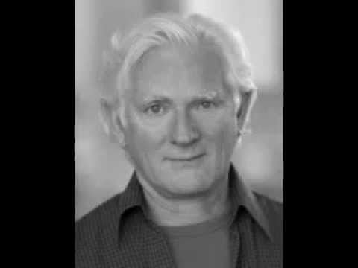

One physicist working on the issue of transcommunication was Burkhard Heim. One cannot exclude that perhaps Heim had developed an intuitive ability, which focused his research, as he lived with severe hearing and visual disabilities, disabilites that led him to resign from the prestigious Max Planck Institute for Physics under Wiesacker after receiving his Ph. D. In Physics from Gottingen, after the war the KWI Institutes were renamed after Max Planck. He was a type of misfit wunderkind with chemicals and especially thermite explosives, after a school prank with toy explosives he was kicked out at age 14. He was recruited by Goring after submitting ideals regarding explosives to the Chemical-Technical Institute of the Reich in Berlin-Tegel while serving in the Luftwaffe in Italy, a type of nuclear detonator, then put in touch with Heisenberg, to work on thermite explosive devices for the Wehrmacht, as a very young man, 19, he led his own team. It was his love of thermite that led to his disabilities as he was loading a thermite explosive for testing, a sound alarm warning of air raids, a false alarm, went off. The vibrations triggering the explosives he held in one hand, instinctively he covered his neck with his other hand, both hands were blown off, otherwise he would have been decapitated by the explosion. Luckily, for Heim, aside from covering his neck, the plant doctor was on his one day a week onsite duty, and prevented massive blood loss and saved Heim’s life. (Ludwiger, 2001, 5-6)
Later in 1952 he began lecturing on his ideals regarding a new propulsion system which gave him some momentary noteriety. Which also placed him under surveillance by the intelligence services (Ludwiger, 2001, 9). He received personal and financial support from Ludwig Bolkow of the aerospace and defense contractor, Messerschmitt-Bölkow-Blohm (MBB) starting in 1958, from which he was able to hire an electrical engineer to assist with his experiments short term. The US Government was even interested in Heim, with an early review of Heim theory in the technical publications of the USAF from 1961. One would think that with such patronage as Heisenberg and von Wiezsacker that Heim’s academic credentials would be secured. Heim and his ideals regarding gravity, propulsion and transcommunication have had a steady opposition from the start. One modern example includes a former Physicist, Dr. Holm Hummler [https://www.youtube.com/watch?v=lqR2S8yxfFM ], he left science in 2001 to works for Boston financial interests, the Boston Consulting Group, He has been the owner and managing director of Uncertainty Managers Consulting GmbH in Bad Homburg, near the banking center of Frankfurt, since 2007 (Hummler, 2018). He goes around specifically debunking Heim theory as pseudoscience and is a self-marketed ‘skeptic’, among other things he ‘debunks’ are technological conspriacy theories. So once again, we find another gravitational theoretical physicist being suppressed and again we see some connection to the same original social networks of the Boston financial interests.
As mentioned in the Jordan section, Jordan and Heim collaborated together. Heim and Jordan were both educated at Gottingen, both have common connections with von Weizsacker, who was imprisoned in Britain for a year after the war as a member of the Nazi Bomb team. Jordan and Heim have extensive theories and emphasize the role of Gravity, both were seeking a physical explanation for transcommunication using gravity. So it is no wonder that they would eventually collaborate. Jordan was in attendance when Heim presented his theoretical physics for a symposium for the staff of MBB at Ottobrun in 1969. At that time Jordan was a advisor on Aerospace propulsion for MBB and others, important to remember Jordan had one a GRF award for a paper on faster then light propulsion. Jordan and Heim were to conduct a experiment on measuring gravity, but it did not receive sufficient funding at the time and the experiment was superceded by other experiments and never conducted. Like Jordan, Heim also collaborated with the former SS member and scientist Dr. Hans Bender who scientifically investigates psi phenomenon and specifically worked with Heim on a scientific theory of ‘transcommunication’.
Many physicists have come up with hyperdimensional explanations of our physical reality, like Klein-Kaluza theory from the 1930s, the original hyper dimensional explanation. Heim too comes up with a theory based on hyperdimensions, 6d. Ludwiger notes regarding 6d that Roger Penrose has also come up with a similar concept, we will read about Penrose’s ideals on Quantum Consciousness, where gravity plays a role in determining the final Quantum State later:

Incidentally, the mathematician Roger Penrose, Stephen Hawkings' teacher, has come across 3 real and 3 imaginary dimensions of the world as well. He discarded his complex C3-world, as he could not interpret the two additional imaginary dimensions physically. Should there be 3 time dimensions? How should they be discriminated from one another? However, if they are not time directions, what are they? And why can't they be temporal dimensions? Xiaodong Chen, a student of Penrose, found that in a R6 at least the wave-particle-dualism... (Ludwiger, 24)

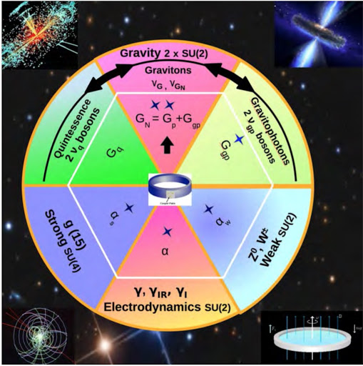

Heim’s 6 Fundamental Forces: Strong, Electrodynamic, Weak and Gravity in 3 modes; Quintessence, Gravity, Gravitophotons

Another participant at the MBB lectures, at the time an engineer working there, Dr. Illobrand Ludwiger, who later became an adept of Dr. Heim’s theories, has given the following succinct overview of Heim’s contribution to theoretical physics:

- a unified phenomenological field theory in which electro magnetism and gravity have been united by Heim,
- a unified quantum-geometric structure theory that has led to a formula for the calculation of the masses of elementary particles, and
- development of an aspectual logic by means of which both the quantitative-physical as well as the qualitative-organisational part of the world can be uniformly described.

At the end there emerges a new world view with the following predications:
- we live in a 6-dimensional world,
- elementary particles are 6-dimensional, dynamic, metric structures,
- humans, too, are 6-dimensional creatures,
- there wasn't a big bang, but the universe developed from a simple space cell,
- the organization in matter is governed by qualitative structures from the 5th world coordinate, - - an approach for solving the body-mind-problem,
- autonomous structures of consciousness can exist free from a material carrier. (Ludwiger, 2001, 11)

In the 1950s the main achievement for which Burkhard Heim achieved a degree of recognition was his discovery of a new propulsion concept for space flight. According to this concept, it should be possible to have a spaceship powered by specially generated gravitation fields and by conversion of electromagnetic waves – instead of by use of chemical fuels. Heim had discovered a phenomenological explanation of gravity as well as a connection to electromagnetic fields. By analogy with Maxwell’s theory of electromagnetism, he had interpreted gravity as a physical field. (Ludwiger, 2001, 13)

Heim notes that, “temporally variable magnetic fields should also be able to generate gravitation fields.” Which is significant in that it presages the ideals of Gerstenshtein Effect by a decade, where EM is turned into Gravity and Gravity into EM. This may also be related to the findings of Dr. Persinger that variable magnetic fields are used in ‘remote sensing’ and ‘deep correlation’.

As mentioned previously, the aerospace defense contractor, MBB, was interested in Heim from at least 1958. He periodically briefed MBB engineers on his gravity based physics. According to former MBB engineer, Ludwiger:

“Only as of 1985 the aerospace company MBB seized on Heim's idea, and wanted to furnish the experimental proof that rotating masses can generate magnetic fields. In a laboratory experiment the weak magnetic field generated by means of a rotating crystal ball should have been proved with a Squid magnetometer, which is a highly sensitive detection device. However, the money necessary for that device couldn't be raised. (Ludwiger, 15)

As noted before Einstein’s GR does not supply a complete answer for the role of Gravity in our Universe, and it still remains in 2020 an open question how Quantum Gravity works exactly. Heim developed a Contrabaric Equation, first formulated in 1955, which is used by other researchers in faster then light propulsion. Ludwiger notes regarding the equation:

As he factored in the field mass of the gravitation field (which Einstein had neglected due to its insignificance), Heim obtained his so-called contrabaric equation. According to that equation, the transformation of electric or magnetic fields into gravitational acceleration fields and vice versa should be possible (Ludwiger, 2001, 14)

It is interestsing that in the 1950s he is already contemplating issues that would later be written of by the likes of Russian Physicist, Gerstenshtein, regarding Gravity in 1962. Yet, there is an almost total absence of knowledge of Burkhard Heim, for reasons such as having to live in isolation due to his disabilites, and not wanting to publish in Academic journals without experimental results to back up his theories. Unfortunately, he did not live into the era we live in now where Gravitational Science is taking off and taken more seriously after the confirmed discovery of Gravitational Waves in 2015, published 2016.
Heim directly worked with transcommunication, which is an important part of any Neuroweapon platform deployed today. He was contacted in 1966 by Dr. Hans Bender, Ludwiger notes regarding this collaboration:

When in 1966 the well-known parapsychologist professor Hans Bender asked whether he would be willing to help him with his physical knowledge with interpreting the “tape-recorded voices”, Heim agreed. In Sweden, together with his assistant W.-D. Schott, he assessed the claims made by Mr. Jürgenson who heard unexplainable voices on tape and on the radio, voices that seemed to address him personally. As these experiments weren’t performed scientifically correct, Heim himself did experiments in his laboratory, which, however, he only rarely talked about. He despised people who carelessly went public with undistinguished results.
In 2010, the physicist Holger Klein found several hundred manuscript pages in Heim’s legacy in Northeim which had been administered by Heim’s foster daughter Ingrid Hartung until her death in the same year. Not only did these pages contain hundreds of Heim’s experiments regarding the validation of transcommunication, but also approaches for a theory of transcommunication. No mainstream physicist would ever dare to start such a kind of work.
As in the 6-dimensional theory all physical field sizes are 6-dimensional, too, Heim derived a possible influx of the additional components x5 and x6 to the moduled phonetic sequence density from the 6-dimensional radiation vector that is transmitted by radio stations. He did this in such a way that in considering the required aerial properties for the trans-components of the radiation vector a modified spoken text can be received as a matter of principle.
In doing so, Heim created first approaches for theoretically comprehensible experiments of a paranormal kind. (Ludwiger, 2001,78)

Yet, it gets weirder for Burkhard Heim, as has been indicated with other scientist, some feel that they are interacting with a superior intelligence while researching and being in a sense directed in their research. Heim while working on his Logics, he was working on ‘Syntrometric Telecentrics of Maximes’, a book on formal logic, that was unpublished but presented at MBB in 1976 with Jordan present, he speaks of being in communication with an extrinsic intelligence, which of course would match the description of a Targeted Individual who hears either positive or negative feedback from ‘voices’:

The work on it was so difficult for Heim that sometimes he himself was not able to understand himself anymore. On July 19, 1974 Heim talked about his experiences ....
‘As I cannot write, I dictated the derivations I did in my head to my father, walking up and down in the room. And during this, I sometimes got a very strange feeling: I couldn’t say “I’m dictating this” and “I’m thinking this”, but “IT is dictating. IT’s thinking!” It was something that apparently didn’t belong to me at all. It seemed to me as I was only repeating something that actually belonged to something completely elsewhere. That’s a weird feeling! I have never talked to anybody about this, as I said to myself, nobody would understand anyway. (Ludwiger, 2001, 67)

Sometimes – and that’s the most creative moments you can have as a human being – you have the feeling as if you’re only the tool and you say, dictate or write something that actually doesn’t originate in you. That has happened to me more than once while I was dictating these notebooks that I later further worked on in more detail. I always had the feeling that completely foreign thoughts were approaching me which only had to be recorded. But I was never able to tell where that came from. That only happened some times, strangely always in such moments where it seemed that I was at a loss. Then it happened.” (Ludwiger, 2001, 74)

As can be seen from Burkhard Heim’s studies and findings the science of Transcommunication is directly related to Gravity. Later, other researchers picked up on Heim’s original theories. Droscher and Hauser have used his theories to create ‘Extended Heim Theory’ (EHT). They even won an award, American Institute of Aeronautics and Astronautics' Future Flight prize, for a paper in 2010 that argues for faster then light propulsion based of this. However, it would take some x-ray generation, pulsed high power beam, to get it done as Roger Lenard of Sandia Labs has stated regarding the proposal:

*Roger Lenard, a space propulsion researcher at Sandia National Laboratories in New Mexico does think it might be possible, though, using an X-ray generator called the Z machine which "could probably generate the necessary field intensities and gradients". (Haines, 2006)

Although this is one way of doing new propulsion, it may or may not be the way. Without adequate funding for experimentation we may never know if Heim Theory is accurate or innacurate, as it has not been tested it is too early to be a protaganist or antagonist of the Heim Theory. As knowledge and interest in working with gravitational technology is relatively new and under researched since it took so long to even confirm their existence, an entirely different or unknown process may emerge from gravitational research, especially at the quantum level, that may be the real answer. Although, it is true many supporters of UFO encounters claim that different governments in the world already have this technology if it is gravitational based then when it exists may be completely irrelevant, with the real question who has the capability and when?

The search for the validation of Gravitational Waves was a bumpby one. In the next section we will review the history for the confirmation of Gravitational Waves by examining the work of American Dr. Joseph Weber.

The Bumpy Road to GW Detection:

The topic of Gravitational Waves was for a very long time a controversial topic in Physics. Many doubted they even existed, until confirmed in 2015 by LIGO. The story of the building of LIGO itself is full of ‘intrigue’, ‘disruptions’ and ‘delays’. The controversies dealing with the detection of Gravitational Waves and general gravity theory and quantum gravity research extends to at least the 1930s, noting the execution by Stalin (a repeated pattern in dealing with the topic of Neuroweapons research in the Soviet Union) of the theoretical physicist Bronstein then working on advanced theories regarding gravity. The controversy extends to the first claims of actual detection of GW by the American Naval Academy graduate Dr. Joseph Weber. Below is a brief timeline of Gravitational Wave Suppression:

On Jan 19 1949 Roger W. Babson founded Gravity Research Foundation dedicated to the science of Gravity, a gravity centric physics research institute. It was attacked by the scientific community, in part due to faster then light propulsion studies, because of the villification, Babson went on to start a new institute to study gravity, although today the GRF enjoys credibility in the scientific community. An interesting aside is that Pascual Jordan, writing on faster then light propulsion using gravity, was an award winner in the GRF’s annual competition for best Gravity related research paper. Babson’s new Institute for Field Physics (IOFP) was headed by Dr. DeWitte in Chapel Hill, North Carolina (UNC). It started the prestigious General Relativity conferences, which began in 1957, GR1. The first conference titled ‘The Role of Gravitation in Physics’ drew such highly regarded physicists as Wheeler and Feynman. Another participant was US Naval academy graduate Joseph Weber. One of the chief questions of this conference was whether gravitational waves can produce work, or energy. Later, it was confirmed they do, do work or have energy.

In 1960, Joseph Weber publish on how to detect gravitational waves. His ideal, among others such as interferometric, was to use a resonant antenna (a hollow cylinder) to detect low frequency gravitational waves. He had built two detectors seperated by 950km one at U of Maryland the other in Chicago at the Argonne National Laboratory. He was assisted by his students, Dr. Forward and Dr. David Zipoy. Dr. Forward went on to play a seminal role in interferometric methods and with High Frequency Gravitational Waves. In 1969 Weber published a paper claiming to have detected Gravitational Waves. Subsequent to this attempts at replicating his experiment proved invalid. Because others were not able to replicate his results he was viewed as a fraud by the scientific community, although later rehabilitated and honoured by the 2016 ceremony announcing the confirmed existence of gravitational waves. It should be pointed out that the replication attempts were flawed in several respects and were not a genuine replication of his approach. For instance, he used a 3 ton cylinder, others 1.5 ton cylinder made of different materials, he placed his in a sealed vacuum, others did not. Gravitational Wave research diminished after this point, while simultaneously being investigated in secret Military Defense projects of the UKUSA and USSR.

Heinz Billing, former Nazi computer engineer and physicist, works to discredit Weber on claim of Gravitational Waves. He is involved in early attempts at building interferometry projects, all of which faced difficulties during his involvement. Also involved in discrediting Weber was an IBM scientist, Richard Garwin, he was noted for his highly aggressive derision towards Weber’s gravity wave claims, based on the claim that Weber’s computer program had a bug creating the readings. Former Nazis were not alone in discrediting Weber, also not able to replicate his results was the Soviet Physicist Braginsky, which of course we note that Bunin’s Gravity Wave signal generator was built in 1972, was the Soviet criticism of Weber also a form of technological obfuscation of actual military capabilities?

In 1975, Heinz Billing lays plans for Gravitational Wave detector, he is working with the Garsching Group to build an interformetric system for detection, later contacted by NSF regarding Weiss plans, see below. Billing’s project tries for 30 years but never detects GW. Apparently, noise was too costly although the noise suppression technology developed did lead to LIGO which does detect Gravitational Waves in 2015.

It wasn’t until 1979 with the announcement of the detection of gravitational radiation effects by Joseph Hoston Taylor and Alan Russell Hulse, this proved effects from gravitational waves but did not measure gravitational waves, and thus to an extent rekindled interest in gravitational waves.

Weber’s main method of detection was a cylinder, he also thought of investigating Gravitational Waves with interferometric methods, which became the basis of LIGO. In the following section we shall look at how the interferometric method for measuring Gravitational Waves came into being, the Soviets also built technology using superconductors, also used in Quantum Computation, such as in a Akimov generator or Bunin’s designs for the GW Signal Generator.

Interferometric Detection of Gravitational Waves:

As menitioned the discovery of Gravitational Waves in 2015 was made by LIGO, an American intoerferometric detector. The road to LIGO began with the work of Joseph Weber, his student, Bob Forward, Dr. Weiss at MIT working with the DoD, eventually leading to other projects of the same nature such as the Billing led Garsching Team in Germany.
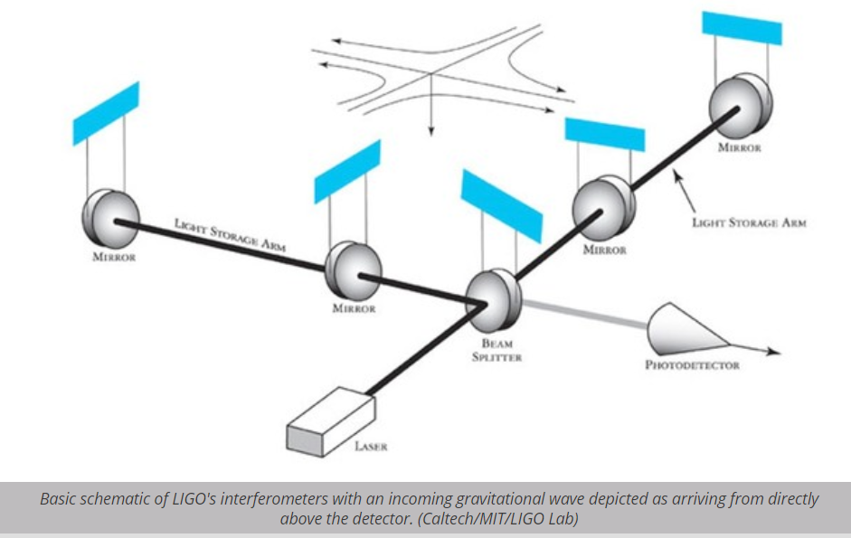

LIGO defines interferometry:

Interferometers are investigative tools used in many fields of science and engineering. They are called interferometers because they work by merging two or more sources of light to create an interference pattern, which can be measured and analyzed; hence 'Interfere-o-meter', or interferometer. The interference patterns generated by interferometers contain information about the object or phenomenon being studied. They are often used to make very small measurements that are not achievable any other way. This is why they are so powerful for detecting gravitational waves--LIGO's interferometers are designed to measure a distance 1/10,000th the width of a proton!
(LIGO, 2020)

Although Joseph Weber wrote about interferometry in his notebooks, he did not publish his ideals. Although, he is credited by Bob Forward with coming up with the ideal. The first to publish on this method was Dr. Gerstenshtein and Dr. Pustovoid in the Soviet Union, they attempted to get the Soviet government interested in supporting such a thing, but were never funded. Again, in 1966, Braginsky attempted to get the Soviet interferometer going for measuring gravitational waves, but again was not supported. It is entirely possible that they had already developed a secret method for this using superconductors like the Akimov generators, this is speculative.
In the United States Rainer Weiss was working on a Interferometer at MIT around 1968. He came up some of his first theories on this method, funded by the DoD, the funding had to be dropped because a new law banned the DoD from funding college research not directly related to military purposes, the Mansfield Act. Later, he would become pivotal in the creation of LIGO, he was named the 2017 Nobel prize for Physics for his work on LIGO. In California, Dr. Bob Forward at Hughes Research Labs has built a prototype of an interferometer. Weiss bases his 1974 design on Dr. Forwards. In 1971 Dr. Forward builds first prototype of ‘Transducer Laser’ which became the basis of LIGO.
In 1974, Weiss who is trying to build his own prototype requests from the National Science Foundation for a 9m prototype. NSF asks the German Max Planck Institute to review the proposal. Eventually landing in Heinz Billing’s lap. His team, Garching Group, builds a prototype on their own. The Garching Group never detects Gravitational Waves but it does develop noise suppression system that was used on the LIGO detector. Weiss sent his assistant Dr. David Shoemaker to work with the Garching Group. In 1975 NSF funds Weiss’ detector. Weiss plan was to develop the detector in stages with aLIGO, a prototype and bLIGO a production detector, which did go on to detect Gravitational Waves.
So it took from 1960 to 2015 to go from ideals of detecting gravitational waves to their final authoritative confirmed finding by LIGO. This may seem like an long time to go from theory to measurement. Indeed, there have been many unforeseen delays in the detection of Gravitational Waves, from funding problems, mismanagement and intense personal conflicts, for instance LIGO was managed by Weiss and Drever, but they had intense interpersonal conflicts leading to more delays as noted by one scholar:

The Caltech–MIT project was funded by NSF and named the “Laser Interferometer Gravitational-Wave Observatory,” known by its acronym LIGO. The project would be led by a triumvirate of Thorne, Weiss, and Drever. Soon interactions between Drever and Weiss became difficult because, besides the strenuous nature of their interaction, both had differing opinions on technical issues. During the years 1984 and 1985 the LIGO project suffered many delays due to multiple discussions between Drever and Weiss, mediated when possible by Thorne. In 1986 the NSF called for the dissolution of the triumvirate of Thorne, Drever, and Weiss. Instead Rochus E. Vogt was appointed as a single project manager . (Czervantes-Cota, 2017)

Whether, it is the killing off of Gravitational Theoriests during the Stalinist purges or building a detector or trying to improve communicatons with HFGW, as we shall see later, there is much Gravity in the way of researching Gravity.

Gravitational Waves and Surveillance

In Intelligence gathering, say visual surveillance, a question of resolution is always an issue. The desire by agencies to increase their resolution of recon satellite images is something that is always a technical challenge to be improved on. Resolution is also important in terms of Neuroweapons, or any weapon involving any basic targeting, to hit the target with the most precise accuracy is always desirable in the field of warfare. There are two ways covered in this work to gain high resolution through using waves: 1. Time-Reversed Radar Waves and 2. High Frequency Gravitational Waves.
In 1961 Dr. Robert Baker, who lived and grew up near the cornerstone of aerospace defense contractors in sunny California, a childhood friend of the Douglas family (McDonnell-Douglas) and the Grumman (Northrop-Grumman) family. He later after graduating from UCLA worked for Lockheed. It was while working for Lockheed Astrodynamics Research Center (LARC) that Dr. Baker made the first presentation on High Frequency Gravitational Waves that is known, according to Dr. Baker he presented his finding to Lockheed engineers, along with Weber assistant, Dr. Bob Forward, who worked at nearby Hughes Research Lab, who lectured on interferometric methods. Dr. Baker writes:

The first mention of High-Frequency Gravitational Waves or HFGWs that I could determine was in a Lecture in 1961 that I had given with Dr. Robert Lull Forward at my Lockheed Astrodynamics Research Center in Bel Air, California. [Lecture given at the Lockheed Astrodynamics Research Center (LARC), 650 N. Sepulveda, Bel Air, California, USA, a few blocks from UCLA, November 16th. Lockheed Research Report RL 15210, based upon notes taken by Samuel Herrick a Lockheed Consultant and UCLA Professor. Attendees included LARC members Robert Rector, Professors Geza Gedeon, Kurt Forester, my secretary Joan Boyle who typed up Herrick’s notes in the Lockheed Research Report of the Lecture, plus UCLA students.] I had invited Dr. Forward over from the Hughes Research Laboratory in Malibu, California to deliver a lecture on the “Weber Bar” that he and Dr. Joseph Weber were constructing at the Hughes Lab to detect Low-Frequency Gravitational Waves (1660 Hz). During the Question and Answer part of our Lecture, Bob Forward and I talked about building a Laboratory generator and detector for “High-Frequency Gravitational Waves,” having frequencies over 100 kHz. As far as I know this was the first time the subject had been broached. I recall that we concluded that it could not be accomplished with the technology then available; but I suggested that such high-frequency gravitational waves, or HFGWs, would have practical applications, for example communication (the ultimate wireless system).” (Baker, 2017)

Original Source Material: Forward R.L. and Baker R. M L (1961), “Gravitational gradients, gravitational waves and the ‘Weber bar’,” lecture at Lockheed Astrodynamics Research Center, Bel Air, California, , 650 N. Sepulveda, Bel Air, California, USA, November 16th. Lockheed Research Report RL 15210. (Forward coined the term “High-Frequency Gravitational Waves.”)

As always in science the issue of who takes credit for an ideal or invention is always a high prestige item for engineers. The first written paper on HFGW was by a Soviet Researcher, in 1962. Mikhaeil Gerstenshtein ‘Wave Resonance of Light and Gravitational Waves are HFGW’ A paper on HFGW regarding converting EM to HFGW and HFGW converting to EM. Which became known as the “Gerstenshtein Effect”. An important note regarding this is that later this effect will be misapplied in a suppression effort against another HFGW technology based on the “Li effect” in the US DoD and Intelligence Community circles JASON Reports.

It was in 1964 that HFGWs were written of in relation to investigating the Big Bang. Leopold Halpern and Bertel Laurent publish on Big Bang having relic HFGW. Suggested a gasser Generator of HFGW analogous to EM Wave generation by lasers. Then in 1974 – Leonid Grishchuk, Mikhail Sazhin ‘Emission of Gravitational Waves by an Electromagnetic Cavity’ involved HFGW. The Soviets did research in HFGW during the cold war. Which draws attention to the very important concept of EM Cavity, of which there are many natural biological correlates too. In other words we can find EM Cavities in Biology, such as proposed by some researchers for Microtubules in the Brain. It should be pointed out in regards to the Soviet use of Gravitational Wave signal generators that those generators were of a Low Frequency nature not HFGW.

The first UKUSA based HFGW detector was created in England by Professor Cruise:

One of the first practical HFGW detectors was developed at Birmingham University, England by Professor Mike Cruise and his graduate student Richard Ingley. Professor Cruise published his years of research in 1983 and during the 1990s on an electromagnetic detector for very-highfrequency gravitational waves, in Class. Quantum Gravity in 2000. Professor Cruise has published over 100 research papers and a textbook on The Principles of Space Instrument Design. He is a member of the European Space Agency and a member of international teams searching for gravitational waves using ground based and space based facilities such as LIGO and the proposed Laser Interferometer Space Antenna or LISA. An interaction between a gravitational wave and the polarization vector of an electromagnetic (EM) wave is the basis for the Cruise-Ingley Birmingham HFGW detector. The polarization vector of the EM wave rotates about the direction of its propagation. If a resonant condition can be established with the EM wave always experiencing the same phase as the gravitational wave, then the effect is cumulative and can be enhanced linearly by repeated circuits of a closed loop. The detector measures changes in the polarization, using a short filament or probe, of the EM microwave beam (indicating the presence of a HFGW) propagating within a waveguide loop about one meter in diameter. This is about the wavelength of 300 MHz HFGWs. A pair of the CruiseIngley HFGW detector loops is shown in the slide. [A. Michael Cruise (1983), “An Interaction between gravitational and electromagnetic waves”, Monthly Notices of the Royal Astronomical Society, Volume 204, pp. 485-482. A. M. Cruise (2000), “An electromagnetic detector for veryhigh-frequency gravitational waves,” Class. Quantum Gravity, 17, pp. 2525-2530. http://dx.doi.org/10.4236/jmp.2011.26060 R. M. J. Ingley and A. M. Cruise (2001), “An electromagnetic detector for high frequency gravitational waves,” 4th Edoardo Amaldi Conference on Gravitational A. M. Cruise and Richard M. J. Ingley (2005), “A correlation detector for very high frequency gravitational waves,” Class. Quantum Grav. 22, 5479-5481. M. Cruise (2007), “Operational Performance of the Birmingham 100 MHz Detector and Upper Limits on the (Baker, 2017, 10-11)

Another detector was created in 1998 in Italy – Giorgio Fontana HTSC Gazer:

Giorgio Fontana in Italy had been studying another possible HFGW laboratory generator also similar to a Laser that he termed a “HTSC Gazer.” His high-temperature superconductor or HTSC generator is based upon the previously mentioned Halpern and Laurent studies and “... the 16 ©2017 R. M L Baker, Jr. properties of cooper-pair pairing states …” [Giorgio Fontana (1998), “A possibility of emission of high frequency gravitational radiation from junctions between d-wave and s-wave superconductors,” Preprint, Faculty of Science, University of Trento, 38050 Povo (TN), Italy, pp. 1-8. http://xxx.lanl.gov/html/cond-mat/9812070. Giorgio Fontana and Robert M. L. Baker, Jr. (2003), “The high-temperature superconductor (HTSC) gravitational laser (GASER),” paper HFGW-03-107, Gravitational-Wave Conference, The MITRE Corporation, May 6-9.] (Baker, 2017, 15-16)

Shortly thereafter, Dr. Baker along with Dr. Li patented their collaboration on HFGW in 2000 -First Patent in US and China for a HFGW Generator by Dr. Li and Dr. Baker (filed July 14, 2000, granted July 19, 2002)(Baker, 2010, 33)
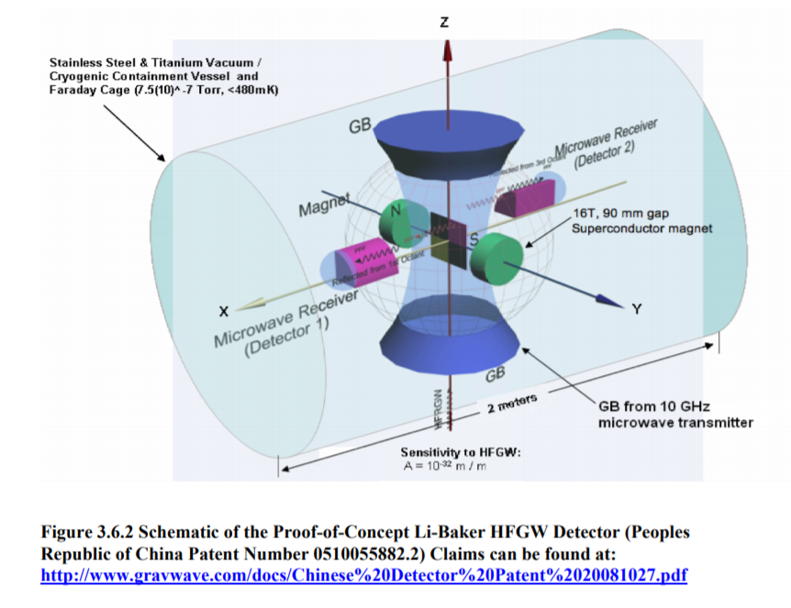
Baker also filed a patent for ‘Gravitational Wave Generator Utilizing Submicroscopic Energizable Elements (filed Dec. 27, 2000) (Baker, 2005). In 2004 issued a patent for generating HFGW using x-rays, which was a method noted by researchers on anti-gravity technology as being a necessity for creating anti-grav tech, Lockheed-Sandia labs in New Mexico operates a X-Ray generator for weapons development, the “Z-Machine”. In this particular submicroscopic version Dr. Baker sees the ability to change cellular nuclei, etc. Along the lines of earlier work in microbiology during World War 2. It is also interesting to note that Dr. Baker foresaw this technology as a means of transferring thoughts, and his company GravWave LLC has partnered with the French company Exobiologie on thought transference, as described by Lockheed engineer Dr. John Norseen in a previous chapter] using HFGW from one person to another, see http://www.exobiologie.org. Which in it’s premiere Academic conference has the following program for 2020: “Brain to Brain exobiological communication by High Frequency Gravitational Waves. (Gary V Stephenson - Physicist and engineer, Gravwave team)” (web site, accessed 7/28/20). The Exobiologie documentation references the work of Daniel Bar of Bar Ilan University in Israel who in 2007 first proposed publicly the concept of gravitational brain waves. Noting that:

“For the first half of this work we have used the fact that the ionic currents and charges in cerebral system radiates electric waves as may be realized by attaching electrodes to the scalp. That is, one may physically and logically assume that just as these ionic currents and charges in the brain give rise to electric waves so the masses related to these ions and charges should give rise, according to the Einstein’s field equations, to weak GW’s. From this we have proceeded to calculate the correlation among an n brain ensemble in the sense of finding them at some time radiating a similar gravitational waves if they were found at an earlier time radiating other GW’s. We have used as a specific example of gravitational wave the cylindrical one which have been investigated in a thorough and intensive way... (Bar, 2007)
Another interesting topic related to Neuroweapons is holography, if after all Gravitational Waves are used for Neuroweapons which are based on remote sensing of brain state, how would one represent such states. Since there are gravitational brain waves, and since according to Bar, who writes on the topic of gravitational wave holography, that:

In our discussion we have used the known methods of opti al holography and, espe ially, the realization that, under certain conditions such as very small wavelength, one can not, theoretically, differentiate between GW and EMW. We have, thus, shown that passing a referen e GW (not in the same region passed by the subje t wave) and letting these two waves meet and interfere in some other spa e-time region (hologram) then if this referen e wave is again passed, as the orresponding EMW illuminator, through this hologram the result will be a re onstru tion of the subje t wave. Although this dis ussion is purely theoreti al one may hope that a future advan ed te hnology will be developed whi h will enable the next generation of s ientists to use and manipulate GW the same way we are able now to use EMW. (Bar, 2005)

Thus, using this holography one could recreate the matrix of GW in Minkowski space (4d). Thus, have a holographic representation of gravitational brainwaves. Additional to that is the recently confirmed gravitational memory effect which as the name suggest leaves an imprint, so to speak, on the local particles of a passing GW, or a memory, perhaps what some mystics call the “Akashic Records”. Theoretically, one could generate a visual map based on gravitational brainwaves, Dubrov’s biogravitation, a map of the brain, as referenced in the work of Dr. John Norseen.
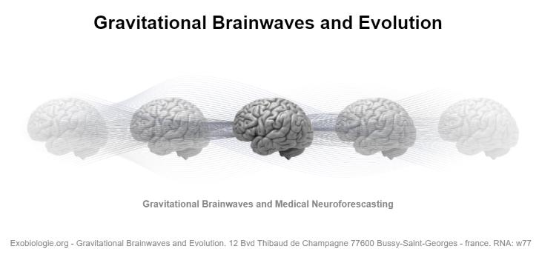
Baker’s GravWaveLLC is a partner of this French company investigating gravitation and brain relationships (image from exobiologie.org)

There basically is no area of research for HFGW outside of the military and IC. Public funding, except to a limited degree is only given in China, there so far have been no major funding in any publicly trackable way for the development of HFGW. In 2000 - in January of Dr. Baker contacted the NSA regarding HFGW technology, primarily focused on using HFGW for surveillance. Later in 2007 he presents on HFGW Surveillance at University of New Mexico STAIF conference. This is in the heartland of government labs such as Lockheed-Martin-Sandia and others.

In the late 1990s and early 2000s Dr. Baker collaborates with Dr. Li in China. Dr. Li publishes on the “Li Effect”, Dr. Baker recounts:

In China Dr. Fangyu Li had accomplished research into the Li effect in which HFGWs in a Gaussian electromagnetic field and an intense magnetic field could allow for the detection of HFGWs. This detector, termed the Li-Baker HFGW Detector, was under initial development in China at Chongqing University. (Baker, 2017, 17) The Li Effect was the basis for Dr. Baker’s work, not the Gerstenshtein Effect which was used to debunk Dr. Baker’s work by the Military Scientific advisor, Yeardley, of the JASON Reports.

the Fangyu Li effect, a gravitational wave transfers energy to a separately generated electromagnetic (EM) wave in the presence of a static magnetic field as discussed in detail in Li et al., 2009. That EM wave has the same frequency as the GW (ripple in the spacetime continuum) and moves in the same direction. (Baker, 2010, 25)

In 2003 a former DIA officer, Paul Murad (M.Sc.), organized a conference on HFGW at a front company for DoD projects, the Mitre Corporation of McLean, VA. The Mitre Conference was the first sponsored, serious symposium solely dedicated to HFGW. Presenters included the leading figures in HFGW, such as Dr. Baker and others. Gary Stephenson who presented on using HFGW for communications, Eric Davis who presented on ‘Laboratory generation of high-frequency gravitons via quantization of the coupled Maxwell-Einstein fields’. Others presented on other issues related to HFGW.
The interesting details regarding this conference was it’s intimacy with the DoD/IC Research community through Paul Murad. Paul Murad, heavily involved in high frequency gravitational waves, started first Mitre Corporation. He is known to have worked for the Defense Intelligence Agency on new technology research. He ran Section-F of the University of New Mexico STAIF conference, dealing with anti-gravitation propulsion and the like. Section F was established by a NASA scientist, Marc Millis, who invited Murad to organize the sectional conferences. (Murad, 2006) STAIF is part of the UNM Institute for Space and Nuclear Power Studies (ISNPS). In an interview regarding his involvement as head of Section-F the issue of Military and Intelligence involvement in the conferences is brought up:

“ I've heard that at the 2004 session there were maybe 40 regular attendees, as well as the somewhat disturbing sight of Air Force officers quietly moving around in the back of the conference room. “

“Murad: The overall STAIF conference in 2004 had up to 750 attendees and we held an audience of regulars for each paper. I am not concerned about military attendees. In fact I have many people from DoD and various government agencies as session chairs and co-chairs is useful because if funding were available, they would be knowledgeable about it.”
(Murad, 2006)

So clearly it is established the Military and Intelligence community in HFGW. Also attending the conference was Jane’s Military Intelligence editor Nick Cook, Jane’s attended conferences between 2003-5. Which is in keeping with it’s mission of providing private intelligence information regarding all kinds of military threats. I often studied Jane’s Warships while on Sonar duty on a US Navy Submarine. One would think with this much interest the United States was ahead of the game. However, Murad paints a different picture, painting the Russians and Europeans as in the lead he recounts of the 2003 Mitre Conference:

“As is typical of Americans, during the coffee breaks, they would sketch a candidate idea for a gravitational wave detector at a given frequency x trying to impress a foreign presenter. The foreigner in one case shook his head and suggested it was a good design and then took out Polaroid pictures showing his test apparatus at frequency x, then y and finally z! These were pictures of metallic hardware representing a gravity resonating cavity that was shock isolated and quite impressive. Clearly, the U.S. had ignored this technology and seriously, if there was any value to this work, we were sorely not even second best.” (Murad, 2006)

This too was the case with Neuroweapons research in general, with the United States having physically out muscled the Soviet Union inherited the Soviet Union research once it collapsed, bringing Soviet Researchers to New Mexico in the 1990s to work on NSA sponsored Neuroweapons research as evidenced by the writings of Dr. John Norseen.

Suppression of HFGW
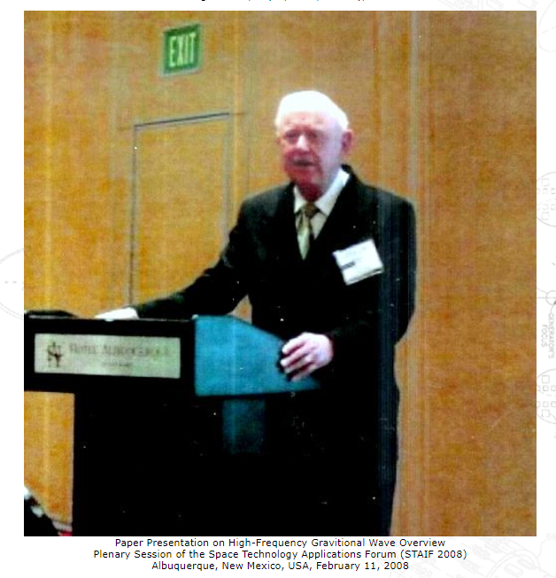
2008 – JASON suppression of HFGW after Dr. Baker in 2007 presents on using HFGW for Surveillance and Military Applications at STAIF in New Mexico.
After the 2nd HFGW Workshop on June 17, 2008, a research group called the JASONs, composed of very influential and respected university scientists, were given a briefing on the generation, detection and applications of high-frequency gravitational waves (HFGWs). The JASON Report (JSR-08-506) on that briefing was published in October 2008. The Report was widely distributed to the US scientific community and various press organizations reported it. The JASON Report stated that “Our main conclusions are that the proposed applications of the science of HFGW are fundamentally wrong; that there can be no security threat; and that independent scientific and technical vetting of such hypothetical threats is generally necessary. We conclude that previous analysis of the Li-Baker detector concept is incorrect by many orders of magnitude …” The author of the JASON Report’s basic premise for generating HFGWs was: “A basic mechanism for generating a HFGW is the direct conversion of an electromagnetic wave into a gravitational one of the same frequency by a strong static magnetic field. This Gertsenshtein process is idealized in Figure 3.” In addition the Report states: “Proposed HFGW detectors have generally been based upon versions of the inverse Gertsenshtein process.” (Italics added by the author for emphasis.) These statements are both incorrect. As already mentioned, the Gertsenshtein process or effect was published in 1962: M. E. Gertsenshtein, “Wave resonance of light and gravitational waves,” Soviet Physics JETP, 14, Number 1, pp. 84-85. The effect is extremely weak and is not utilized in most of the modern HFGW generation, detection or applications. (Baker, 2017, 24)

Once again, it is not surprising, we find some irony in the concept of suppression of HFGW, that occurred after Dr. Baker’s 2007 STAIF presentation. In General, working with gravitational based technology is considered a high risk proposition by many ‘free energy’ researchers, ‘faster then light’ propulsion researchers. According to Lt. Col. Tom Bearden, he himself no longer researches in this area due to concern for his life:

" I'm a co-author of a paper in the literature way back there which reports a successful anti-gravity drive I'm not going to do another experiment not even going to participate in one it's not going to so you know everybody's got a little bit different circumstance and my circumstance for me to go on living and staying healthy and doing well depends on me avoiding certain areas and that's one of them " (Bearden, 2005) https://www.youtube.com/watch?v=eNU3MLqyzPk&t=1359s
Paul Murad, notes where there is not overt suppression there is a general disinterest in HFGW and unneccessary road blocks put in place to publish regarding HFGW:

The culture and the problem set had to change. The major problem was how could one simple person change these things and then I found that I was not alone in these beliefs and surrounded myself with several other kindred spirits with similar ideas. This included Dr. Bob Baker and Tony Robertson. My papers were then being rejected from both AIAA and STAIF because of much stricter selection criteria. For example, papers would only be accepted if I had somebody from academia as a co-author! At this point, going to these conferences were, at least in my view, quite boring. It was as if the technical community had shut down and would become bureaucratic, thereby losing its lust to resolve new and exciting technical challenges. Clearly the technical community was falling into a risk-averse paradigm and apparently there was no way out.” (Murad, 2006)

What is one to make of two members, both former Military Intelligence, of the Gravitational research community painting such a dore picture of research in this field? Could it be directly related to non-disclosure of highly classified military weapons programs being developed by the likes of Lockheed-Martin? Dr. Robert Baker when asked if he believed that the 2008 JASON Report was an attempt at suppression answered rather directly in the affirmative:

Q: Do you believe that the organizers of the GravWave briefing to the JASONs had a preconceived agenda to discredit high-frequency gravitational wave research in general and the GravWave® LLC research in particular?

A: It is difficult to believe otherwise. Ordinarily, an unbiased analysis of a technical presentation would have involved some consultation with the presenters in order to better define the subject matter. Furthermore, an exclusive focus on only one HFGW detector, to the exclusion of the Birmingham University, INFN Genoa and Japanese HFGW detectors, which the GravWave presenters discussed in their PowerPoint presentation, would be unwarranted in an unbiased analysis, as would be the avoidance of a discussion of other HFGW-generator research presented by GravWave. Only one HFGW detector paper was scrutinized by the JASON authors -- their reference [10]. Although never discussed in the GravWave® presentation, the Abstract of that paper did mention the Gertsenshtein effect, but the first paragraph of the actual paper admonished the reader to review the other literature that clearly showed that the detector was the result of a combination of the Gertsenshtein effect with synchro-resonance, the Li-effect and not the Gertsenshtein effect alone. Their avoidance of analysis of the basic reference [11] in their Report, which covered the Li-effect, was certainly unwarranted in an unbiased Report. CITATIONS Eardley, et al. (2008) “High Frequency Gravitational Waves,” JSR-08-506, October, the JASON defense science advisory panel and prepared for the Office of the Director of National Intelligence. (Baker, 2009)

Baker, Robert Military Applications of HFGW 2009 Revision http://citeseerx.ist.psu.edu/viewdoc/download?doi=10.1.1.496.3368&rep=rep1&type=pdf

It is an established practice of nations military defense to obfuscate their own capabilities from others. As well as take technology from original researchers and place it in classified labs of their own. Additionally, if an enemy has such technology it could be used to send enemies down the wrong research trajectory by influencing the reviewers to make basic academic mistakes. Reading the context from the JASON Report they were trying to analyze whether a country like China posed a threat using such technology, from which they concluded no ‘enemy’ possessed such technology to pose a threat. Undoubtedly, the US Military has expressed interest in HFGW at least into 2013, when DARPA issued a call for proposals https://www.sbir.gov/node/386412 (accessed 7/19/20) regarding HFGW communication systems much like Dr. Baker’s. Research conferences continue on the issue of HFGW with the 2017 3rd HFGW Conference in Chengdu, China.

In the following we will review the military applications of HFGW as proposed by Dr. Robert Baker, his main propals are to use HFGW for surveillance and secure covert communications.

Dr. Baker makes some elementary remarks on their significance to the military:

● Gravitational waves have a very low cross section for absorption by normal matter, so HFGWs could, in principle, carry significant information content with effectively no absorption, unlike electromagnetic (EM) waves.
● Because of their unique characteristics, HFGWs could be utilized for uninterruptible, very low-probability-of-intercept (LPI) communications.
● Other potential very theoretical military applications are propulsion, including “moving” space objects and missiles in flight, surveillance through buildings and the Earth itself, and remote initiation of nuclear events. (Baker, 2010, 1)

Regarding HFGW for LPI Comms:

” If we could generate ripples in this space-time fabric, many applications would become available to us. Much like radio waves can be used to transmit information through space, we could use gravitational waves to perform analogous functions. (Baker, 2010, 2)

Of the applications of high-frequency gravitational waves (HFGWs), communication appears to be the most important and most immediate. Gravitational waves have a very low cross section for absorption by normal matter, so high-frequency waves could, in principle, carry significant information content with effectively no absorption, unlike electromagnetic (EM) waves. Multi-channel HFGW communications can be both pointto-point (for example, to deeply submerged submarines) and point-to-multipoint, like cell phones. HFGWs pass through all ordinary material things without attenuation and represent the ultimate wireless system. One could communicate directly through the Earth from Moscow in Russia to Caracas in Venezuela—without the need for fiber optic cables, microwave relays, or satellite transponders… (Baker, 2010, 3) [in this system it is important to note it is terrestrial based]

Any nation that possesses a communication system that is totally secure, high-bandwidth and can propagate directly through the Earth has an economic advantage over nations who do not posses that capability. From a national security viewpoint, they would be able to communicate with little or no possibility of interception. Surprise attacks by enemies of the United States could be planned and executed utilizing such a communications system with impunity. (Baker, 2010, 16)
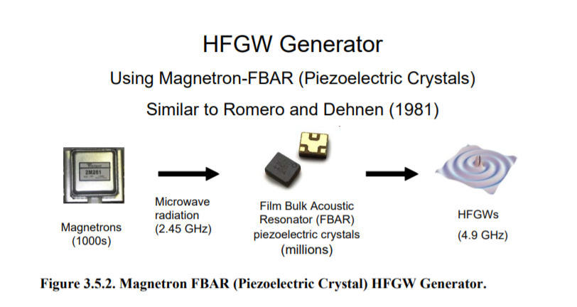
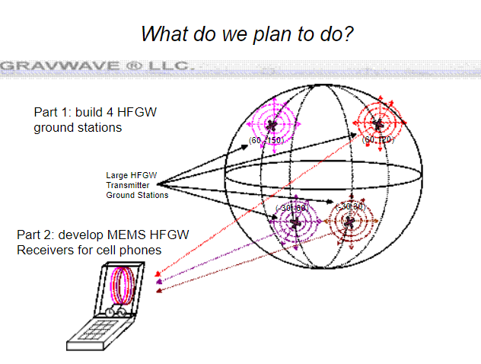
One of the important components of the Li-Baker HFGW detector is the use of FBARs (Film Bulk Acoustic Resonator pairs) which are commonly used in such things as cell phones. FBARs are powered by magnetrons in their design. Through which Dr. Baker plans to miniaturize his technology and put in cell phones, so that each cell phone would have it’s own Gravitational Wave antenna/transmitter, which he envisions for secure communications in a noiseless channel.

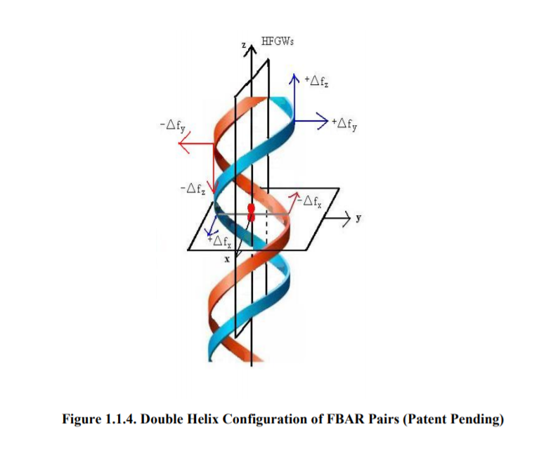
Helical patterns are a common attribute in ‘remote sensing’. See Quantum Consciousness section for further discussion.

Communication is one area that Dr. Baker proposed for Military and Intelligence. Another area was Surveillance, for which he writes:

The potential for through-earth or through-water “X-ray like” surveillance utilizing the extreme sensitivity of HFGW generation-detection systems to polarization angle changes (possibly sensitive to even less than 10-4 radians) might allow for observing subterranean structures and geological formations (such as oil deposits), creating a transparent ocean; viewing three-dimensional building interiors, buried devices, hidden missiles and weapons of mass destruction, achieving remote acoustical surveillance or eavesdropping, etc., or even a full-body scan without radiation danger (Baker 2007a). (Baker, 2010, 9)

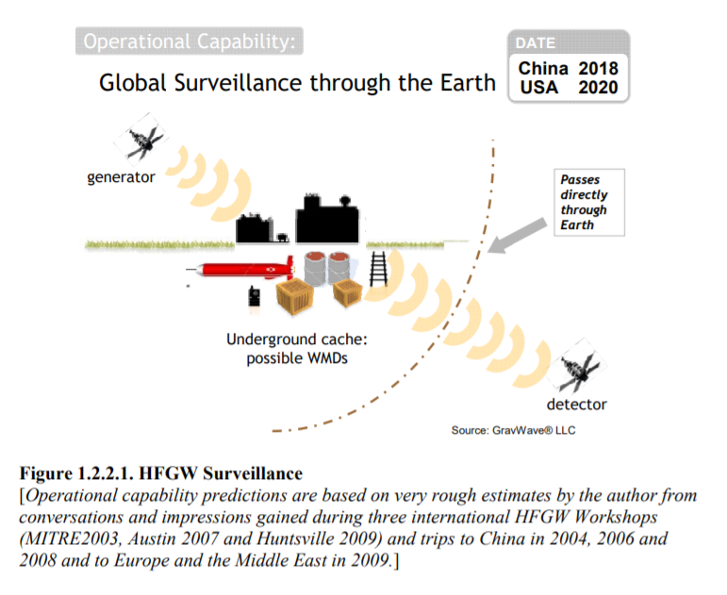
One of the issues regarding using Low Frequency Gravitational Waves is that they cannot be used for surveillance since the resolution is to low for any useful purpose regarding Intelligence collection.

s. The Laser Interferometer Gravitational Observatory (LIGO) and other longwavelength GW interferometer detectors (such as GEO 600, Virgo, TAMA, Advanced LIGO and the planned Laser Interferometer Space Antenna, or LISA) cannot detect HFGWs due to the HFGW’s short wavelengths, as discussed by Shawhan (2004). Longwavelength gravitational waves have thousand- to million-meter wavelengths, which can be detected by LIGO (LIGO is frequency limited to signals below 2,000 Hz and wavelengths longer than 150 km), but these are of no practical surveillance value, due to their diffraction and resulting poor resolution. Furthermore the LIGO technology is completely different from the detection method and noise suppression suggested here. (Baker, 2010, 10)

From the overall picture of Dr. Bakers and others work with High Frequency Gravitational Waves we can see how from at least an academic or prototypical design view point that it is highly possible that HFGW could not only be used for ‘remote sensing’, and as we shall see later, for ‘consciousness’ or using gravitational waves to effect brain function remotely. We can also see clearly how the primary players, at least in the UKUSA countries, is the Military and IC, and no doubt neuro-marketers would be of keen interest to such a technology.

General Timeline on Gravitational Technology:

1905 – First proposed as extension to Newton’s Laws by H. Poincare
1918 – Einstein Gravitational Quadropole (4x4 Tensor). Einstein writes about GW as a quadropole, a quadropolar waves simplest solution that maintains conservation of momentum during propogation of waves. An interesting episode in GW History is the self-denial of Einstein of GW, then re-affirmation of them by Einstein. In 1936 he submitted a paper to a journal denying GW existed, it was met with rebuke by reviewers, never published. In 1937, he revised his position to affirming GW in a new paper with collaborator Rosen. Gravity is quadropolar, EM is bipolar.

1929 – Jordan Kharkov Lecture- spacetime indexed network of local algebras, also interested in gauge theory.

1936 – Jordan Parapsychology paper, a physics of ESP.

1939 – Jordan founds Quantum Biology, Amplifier Theory part of Target

1941-- Jordan plans Nazi Quantum Biology Research on Industrial Scale. Launches Physis Journal in 1942.

1943 – Jordan to Berlin as Professor, works for Navy Research and Patent Office, office secret tech research like Capt. Roeder of Remote Viewing program. In Berlin is able to more closely work with the Berlin Group of the Brain Research Institute: Nikolai W. Timofeeff-Ressovsky (Russian), Karl Gunter Zimmer (later taken to Soviet Union), as well as with Walter Gerlach famous for spin theory experiments, later taken as POW to Britain and debriefed for a year by MI6. Group included phage research as it relates to target theory.

1948 – Jordan post war after the end of needing to be rehabilitated as De-Nazification program had ended, becomes Professor at Hamburg (see cross correlations with Capt. Roeder, the Schroeders and the General acknowledgment as Hamburg being the center of 4th Reich planning.

1949 – Jordan and Hans Bender hold dialogue on physics and parapsychology.

1952 – Burkhard Heim presents his ideals for the first time regarding cosmology and physics. 1955 Habilitation in Physics.

1952 – Jordan publishes Gravity and Space (Schwerkraft und Weltall), textbook on his ideals regarding cosmology and gravity. Cited by Russian L. L. Vasilev as source of Biogravitation. Other possible dissemination of ideals is through Zimmer during forced labor in Soviet prison on Soviet Nuclear Bomb project.

1955 – Zimmer is freed from Soviet prison returns to Germany, he is helped by Jordan to get a Habilatation from Hamburg University, appointed Professor at Heidelberg. He is also helped by Adolf Butenandt and importantly Otmar von Verschuer.

1961 – Baker presents Gravity talk to Lockheed were employed. Dr. Forward (J. Weber’s student) in attendance, credited with promoting research on HFGW later.

1962 – L. L. Vasilev, gravitation theory for psi based on Jordan 1955

1966 – Bender-Heim collaborate on a physical explanation for psi or ‘transcommunication’

1967 – Soviet experiment steering fish schools with gravitational waves

1969 – Heim-Jordan collaborate on experiments on gravity. Jordan works as a consultant for Aerospace research in Germany, he is at Heim lecture on his cosmology at MBB Aero-Defense contractor in Germany.

1972 – in Soviet Union Bunin patents ‘System sending signals using Gravitational Waves’

1973 – Dubrov publishes influential paper ‘Biogravitation and psychotronics’

1976 – Heim again at MBB lecturing, with Jordan in attendance. Jordan works for a ‘Aerospace Technology Group’

1978 – Forward builds the first interferometric detector. “In the early seventies Robert L. Forward, a former student of Jeseph Weber at that time working for Hughes Research Laboratory in Malibu, California, decided, with encouragement of Rainer Weiss, to build a laboratory interferometer with Hughes’ funds.” (Cervantes-Cotta, 2016)

2003 – High Frequency Gravitational Waves (HFGW) conference organized by DIA agent Paul Murad at Mitre Corp (Mildef front company)

2007 – Baker presents at STAIF conference in Albuquerque, NM on HFGW surveillance.

2008 – HFGW debunked by Mitre Corp administered JASON Reports, suspected by Baker as suppression campaign of technology.

2013 – DARPA issues call for proposals for HFGW Communications systems.

---------------------------------

Notes:
[1] Jordan, Pascual (1936) ‘Positivistiche Bemerkungen uber die Parapsychlogischen Erscheinungen’ in Zentrablatt fur Psychotherapie.

Bibliography:

Asprem, Egil (2013) The Problem of Disenchantment: Scientific Naturalism and Esoteric Discourse 1900-1939 SUNY Press

Bar, Daniel Gravitational wave holography (2005)

Bar, Daniel ‘Gravitational Brain Waves, quantum fluctuations and stochastic quantization’ (2007)

Bearden, Thomas ‘Pulling Energy from the Vacuum – Lt. Col. Thomas Bearden (2005) https://www.youtube.com/watch?v=eNU3MLqyzPk&t=1359s

Baker, Robert Search for the Invisible Waves: Brief History of High-Frequency Gravitational Wave Research, presented at 3rd HFGW Workshiop, 7-9th April 2017 Southwest Jiaotang University, Chengdu, China online: https://www.drrobertbaker.com/docs/Search%20for%20Invisible%20Waves%20v5c.pdf (accessed 7/19/20)

Baker, Robert Gravitational wave generator utilizing submicroscopic energizable elements (2004)
https://patents.google.com/patent/US6784591B2/en

Baker, Robert, ‘Military Applications of High-Frequency Gravitational Waves (Abridged)’ (2010)
Beyler, Richard H. (1996) Targeting the Organism: The Scientific and Cultural Context of Pascual Jordan's Quantum Biology, 1932-1947 in Isis Vol. 87, No. 2 (Jun., 1996), pp. 248-273 (26 pages)

Czervantes-Cota, L. Et al ‘A Brief History of Gravitational Waves’ https://arxiv.org/ftp/arxiv/papers/1609/1609.09400.pdf

Dahn, Ryan (2018) Big Science, Nazified? Pascual Jordan, Adolf Meyer-Abich, adn the Abortive Scientific Journal Physis, Isis, vol. 109, no. 4, The History of Science Society

Groß, Armin Heimliche Uberwachung und Strahlenfolter durch Geheimdienste Whistleblower outet sich als ehemaliger Täter in Raum und Zeit #161 (2009)

Haines, Lester ‘Scientists moot gravity-busting hyperdrive’ The Register, 6 Jan 2006
https://www.theregister.com/2006/01/06/hyperdrive/

Murad, Paul ‘The Birth of Section F’, 2006, https://www.americanantigravity.com/files/articles/Paul-Murad-Interview.pdf

Persinger, M., Rouleau, N., Carniello, T. (2014) Non-Local pH Shifts and Shared Changing Angular Velocity Magnetic Fields: Discrete Energies and the Importance of Point Durations. Journal of Biophysical Chemistry, 5, 44-53.
http://dx.doi.org/10.4236/jbpc.2014.52006

Persinger, Michael ‘The Graviton: An Emergent Solution from the Equivalence of Universal Magnetic Field Intensity and Radiant Flux Density’ in Journal of Advances in Physics, Vol. 10, No. 3 (2015)

Schroer, Bert (2003) Pascual Jordan, his contributions to quantum mechanics and his legacy in contemporary local quantum physics
Institut für Theoretische Physik FU-Berlin, Arnimallee 14, 14195 Berlin, Germany

